1. **Agenda**:
   1. How to manage images & containers especially when they are no longer needed.
2. d
3. 
4. Removing containers
   1. **docker rm** <container_name> [ container_name container_name…]
   2. **NOTE**: If you try to remove, a running container, you will get error msg.
      1. Solution: First stop and then remove
         1. Like 🡺 **docker stop** <container_name>   
            Then **docker rm** <container_name>
5. How to remove images:
   1. **docker rmi <container_id> [<container_id> <container_id> … ]**
      1. 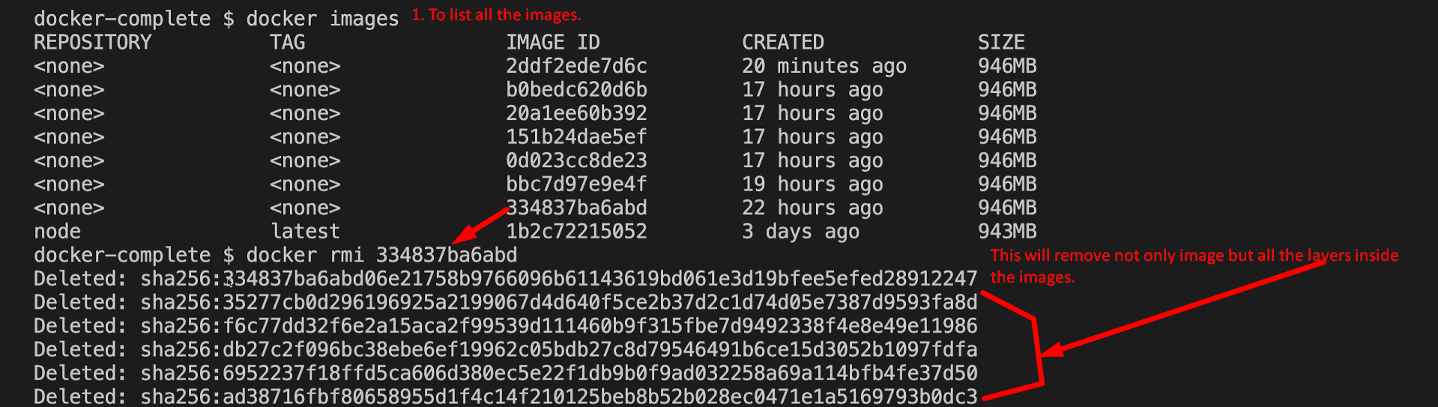
      2. **NOTE**: An image can’t be removed if there is any container based on that image no matter if it is in running mode or stop mode.
         1. **Solution**: First remove all the containers based on that image then remove the image.
      3. **docker image prune:** To remove all unused images.